**Activities to Build ENGAGEMENT**

**Student Learning**

* 12 Powers of Family Business/Family Stories/On the Road to Learning
* Career Fair
* NGSS Family Night
* Parent Workshops
* Grade Level Performance
* Multi-Tiered Systems of Support- Academics (MTSS-A)

**Social-Emotional Development and Growth**

* Positive Behavior Intervention System (PBIS)
* Second Step Curriculum
* Award Assemblies
* Meet Your Teacher Day
* Multi-Tiered System of Support- Behavior (MTSS-B)

**Volunteering Opportunities**

* Classroom Volunteers
* PTA, PTA Family Nights
* GATE Advisory Committee
* English Language Advisory Committee (ELAC)
* District Language Advisory Committee (DLAC)
* School Site Council & School Safety Committee
* Art Academy

**Chino Valley Unified**

**School District**

**What is Home-School Partnerships?**

Home-School Partnerships is an agreement that parents, students and teachers develop together. It explains how parents and teachers will work together to make sure all students reach or exceed grade-level standards.

Effective compacts:

* **Link** to goals of the school's single plan for student achievement
* **Focus** on student learning skills
* **Describe** how teachers will help students develop those skills using high-quality curriculum and effective instruction in a supportive learning environment
* **Share** strategies parents can use at home
* **Explain** how teachers and parents will communicate about student progress
* **Describe** opportunities for parents to volunteer, observe, and participate in the classroom

**PARTNERSHIPS FAMILY PARTICIPATION**

**HOME-SCHOOL PARTNERSHIPS**

**for**

**STUDENT ACHIEVEMENT**

**2023-2024**

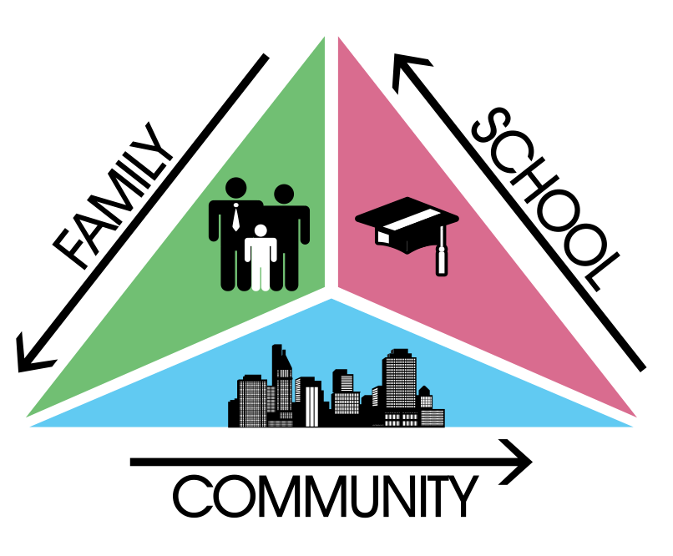

***Fifth Grade***

***Always walk through life as if you have something new to learn and you will.***

***Vernon Howard***

🗺 **15000 Whirlaway Lane Chino Hills, CA 91709**

📞 **(909) 393-4087**

**Learning Compact**

**Communication about Student Learning**

Glenmeade Learning Community is committed to regular two-way communication about our children’s learning. Some of the ways parents and teachers communicate all year are:

**School to Home**

* Newsletters
* School website
* School marquee
* Frequent progress monitoring

**Home to School**

* School agendas
* email
* Parent-Teacher meetings
* Participate In “Activities to Build ENGAGEMENT”

**https://www.chino.k12.ca.us/Glenmeade**

**DISTRICT PARENT RESOURCES**

**Family Engagement Center**

**Adult School, Room 25**

**12970 Third St. Chino, CA 91710**

***WORKSHOPS PROVIDED:***

***EL PARENT ACADEMY***

***12 POWERS OF FAMILY BUSINESS***

***PARENTS AS PARTNERS***

***TRANSITIONS TO…..***

***COMPUTER LITERACY***

***FAMILY LITERACY PROJECT-COLLEGE AWARENESS***

**Family Engagement Center Link:**

**http://www.chino.k12.ca.us/Page/8882**

**909 628-1201 ext. 5601**

**(Spanish) 909 628-1201 ext. 5602**

At Home

**I will provide these activities and/or supports at home to support my child's learning this year.**

* **Encourage your child to write often outside of homework (i.e. thank you notes, lists, letters).**
* **Ask your child to explain what they are learning in math and practice different strategies.**
* **Have your child reference and use Thinking Maps after reading and before writing.**
* **Constantly reinforce school behavioral expectations at home; 3-B’s.: Be Responsible, Be Respectful and Be Safe**
* **Speak with your child about the Second Step lessons taught in class.**
* **Encourage exploration and creativity at home.**
* **Read with your child nightly.**
* **Practice speaking in complete sentences.**
* **Make sure that your child maintains excellent attendance.**

**In the Classroom**

**In our fifth-grade classroom, I will engage all students with a vibrant learning climate and high-quality instruction. Here are some of the student learning strategies your child will use this year.**

**GOAL 1 – Academic Goals**

* **Read with purpose**
* **Refer to text evidence**
* **Use place value and number sense**
* **Compute fractions**
* **Plan and write opinion and informative essays**

**GOAL 2 – Non-Academic Goals**

* **PBIS and school expectations – Be Safe, Be Responsible for own actions, and Be Respectful to others**
* **Setting personal goals**
* **Managing time and materials**

**GOAL 3 – English Learner and Students with Disabilities Goals**

* **Build academic vocabulary**
* **Use of correct grammatical structure in writing**
* **Daily Designated English Language Development**

**Learning Compact**

**Teachers, Parents, Students Shared Responsibility for Learning**

**District Goals - Local Control Accountability Plan (LCAP)**

All students are provided a high-quality teaching and learning environment. Staff, parents, families, and students are connected and engaged at their school to ensure student success. All students are prepared for college and careers beyond graduation.

**School Goals**

**Goal 1- Academic Goal -** All teachers will receive professional development that supports effective instructional strategies in all academic areas.  Calibrating the PLC's understanding of the rigor of each essential standard to ensure the creation of relevant success criteria ("I can" statements).  Relevant success criteria (“I can” statements) are posted and reviewed so that students know what they must know and be able to do to be proficient with the essential standards.  Student self-evaluation using the success criteria at the end of each lesson; student self-reflection at the end of each unit and summative assessment.  Continuing Professional Learning Community (PLC) team format with an emphasis on data analysis to effectively implement "WIN Time" in ELA and Math as it has been developed for Glenmeade students.  Building teacher leadership capacity. **Goal 2 – Non-Academic -** Connections and engagement within our school community will be achieved through the following areas.  1. School Culture - Overall feeling of safety through PBIS school-wide system.  By the April 2023 External TFI, we will score a 2 out of 2 on Tier 2 TFI Feature 2.5 by establishing multiple options for Tier 2 interventions that are documented and using data to assess their effectiveness. This will allow us to increase our participation in Tier 2 interventions to 37 students. (SMART Goal)  2. Parent Engagement - Increased parent engagement, involvement, and leadership will be measured through parent feedback, meeting attendance logs, student attendance data, and student achievement data.  3. School Attendance - Increase student engagement and reduce truant and unexcused absences to increase EOY attendance to 94%.

**Goal 3 – English Learner -** All teachers will provide quality first best instruction, targeted intervention, and evidence-based programs to ensure academic success for underperforming groups of students, including English Learners and Students with Disabilities.  On the 2023 CAASPP, the percent of students scoring “Standards Met” and “Standards Exceeded” (combined) in ELA will increase from 62% to 63%, and in Math will increase from 49% to 53% (SMART Goal).  English Learners and Students with Disabilities will show an increase in the number of students meeting standards according to the Essential Standards Assessments throughout the year and SBAC results at the end of the year.

Our school uses high-quality curriculum and instruction with effective teaching methods to enable students to meet state academic standards. We support our students and work hard to provide a welcoming, safe school environment.

*Our school provides high quality curriculum and instruction in supportive and effective classroom environments to enable students to meet state academic standards. We support our students and work hard to provide a welcoming, safe school environment.*

**Our Goals for**

**Student Achievement**